**COMPUTER ENGINEERING DEPARTMENT**

**SUBMISSION REPORT**

**SUB: Cryptography and System Security**

**COURSE: T.E. Year: 2020-2021 Semester: VI**

**DEPT: Computer Engineering**

**SUBJECT CODE: CSC604 SUBMISSION DATE: 14/05/2021**

==========================================================================================

|  |  |
| --- | --- |
| **Name: Amey Thakur** | **Roll No.: 50** |
| **Class: TE Comps B** | **ID: TU3F1819127** |

**INDEX**

|  |  |  |
| --- | --- | --- |
| **Sr.No.** | **Particulars** | **Submitted/Not Submitted or Enter Marks received** |
| **Experiments** | | |
| **1** | Design and Implementation of a product cipher using Substitution and Transposition ciphers. | 9/10 |
| **2** | Implementation and analysis of RSA cryptosystem and Digital signature scheme using RSA/El Gamal. | 9/10 |
| **3** | For varying message sizes, test the integrity of the message using MD-5, SHA-1, and analyze the performance of the two protocols. Use crypt APIs. | 9/10 |
| **4** | Study the use of network reconnaissance tools like WHOIS, dig, traceroute, nslookup to gather information about networks and domain registrars. | 9/10 |
| **5** | Design a network and implement packet sniffing on telnet traffic using Wireshark. | 9/10 |
| **6** | Implement ARP spoofing using Ettercap. | 9/10 |
| **7** | Download and install Nmap. Use it with different options to scan open ports, perform OS fingerprinting, do a ping scan, TCP port scan, UDP port scan, Xmas scan etc. | 9/10 |
| **8** | Perform SQL injection on a vulnerable website. | 9/10 |
| **9** | Simulate DOS attack using Hoping, hping3 and other tools. | 9/10 |
| **10** | Explore the GPGwin tool and implement email security. | 8/10 |
| **Assignments** | | |
| **13** | Assignment No. 1 | 9/10 |
| **14** | Assignment No. 2 | 9/10 |
| **15** | Assignment No. 3 | Submitted |
| **Quizzes** | | |
| **16** | CSS Quiz 1 | 10/10 |
| **17** | CSS Quiz 2 | 10/10 |
| **18** | CSS Quiz 3 | 10/10 |
| **19** | CSS Quiz 4 | 10/10 |
| **20** | CSS Quiz 5 | 10/10 |
| **21** | CSS Quiz 6 | 10/10 |
| **IAT** | | |
| **22** | IAT-1 | 18/20 |
| **23** | IAT-2 | Submitted |
| **Exit Survey** | | |
| **24** | Course Exit Survey | Submitted |
| **25** | Laboratory Exit Survey | Submitted |

**Signature:**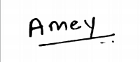

**Experiments**

**CSS Experiment 1**

**Marks: (9/10)**

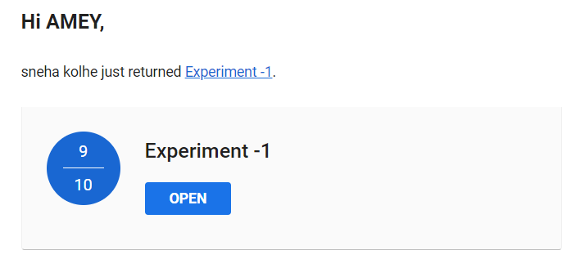

**CSS Experiment 2**

**Marks: (9/10)**

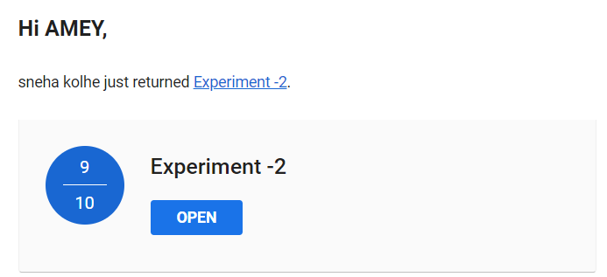

**CSS Experiment 3**

**Marks: (9/10)**

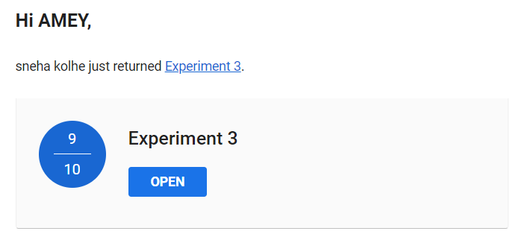

**CSS Experiment 4**

**Marks: (9/10)**

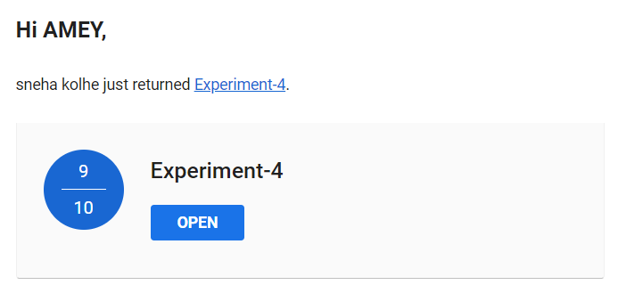

**CSS Experiment 5**

**Marks: (9/10)**

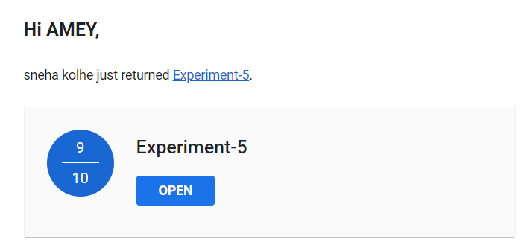

**CSS Experiment 6**

**Marks: (9/10)**

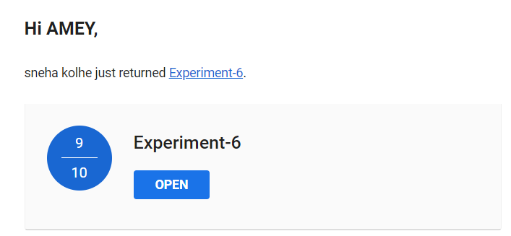

**CSS Experiment 7**

**Marks: (9/10)**

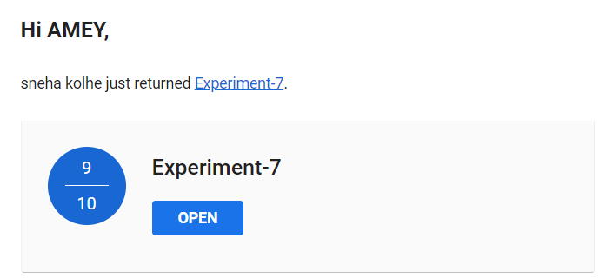

**CSS Experiment 8**

**Marks: (9/10)**

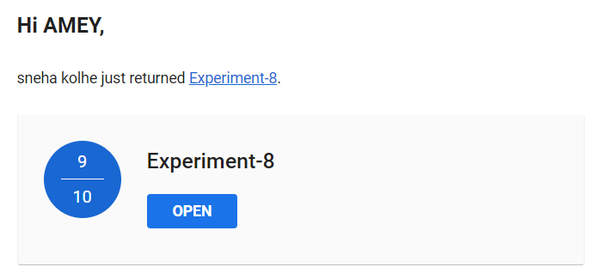

**CSS Experiment 9**

**Marks: (9/10)**

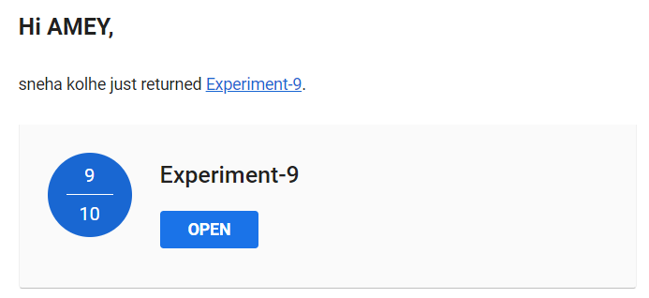

**CSS Experiment 10**

**Marks: (8/10)**

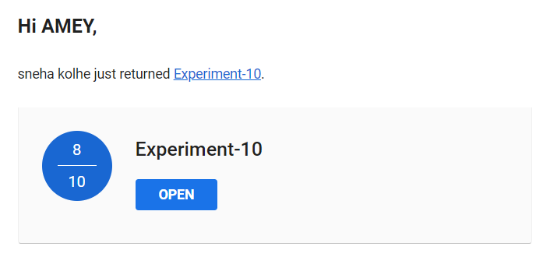

**Assignments**

**CSS Assignment 1**

**Marks: (9/10)**

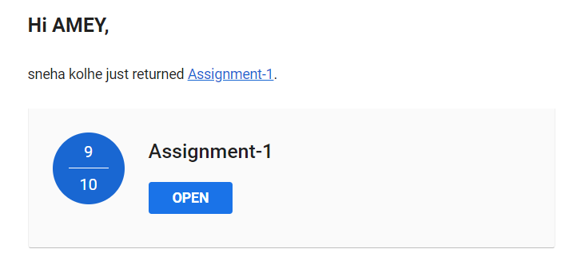

**CSS Assignment 2**

**Marks: (9/10)**

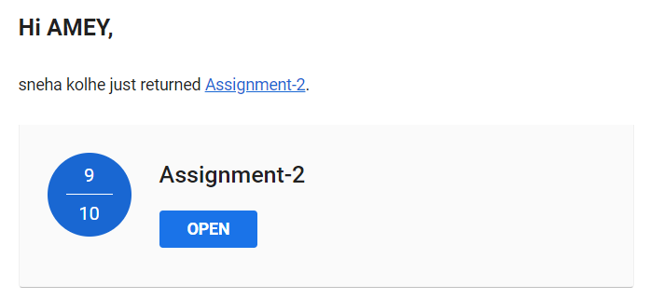

**CSS Assignment 3**

**Marks: Not Received**

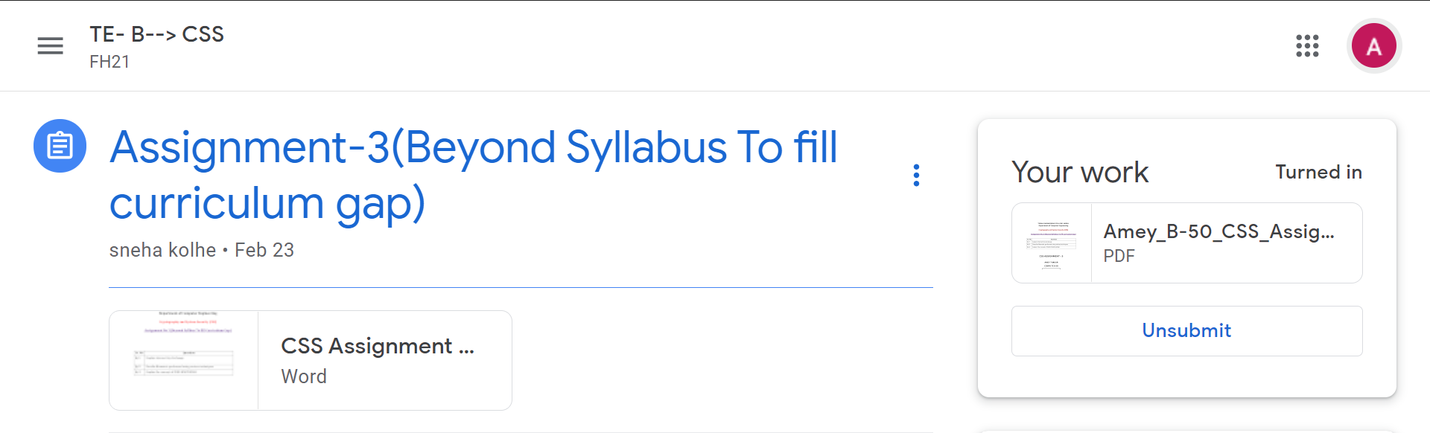

**CSS Practice Test**

**Date: 14/05/2021**

**Marks: (46/50)**

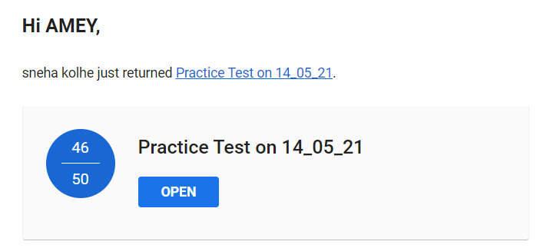

**Quizzes**

**CSS Quiz 1**

**Marks: (10/10)**

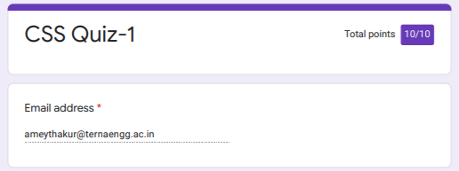

**CSS Quiz 2**

**Marks: (10/10)**

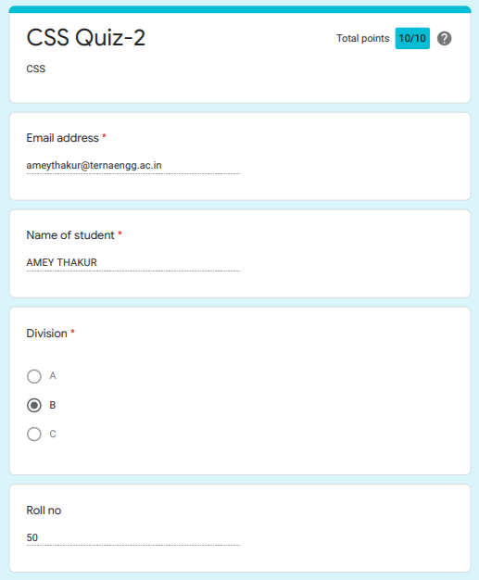

**CSS Quiz 3**

**Marks: (10/10)**

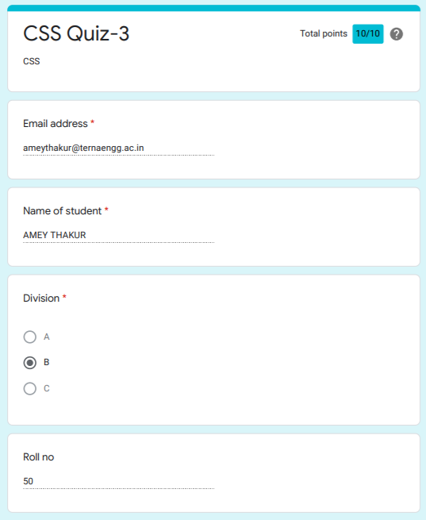

**CSS Quiz 4**

**Marks: (10/10)**

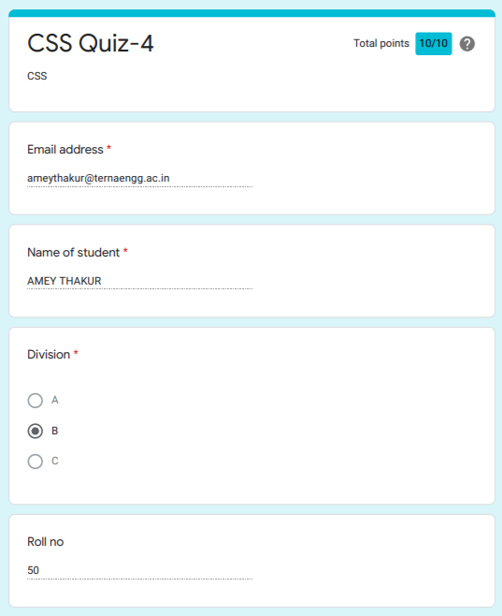

**CSS Quiz 5**

**Marks: (10/10)**

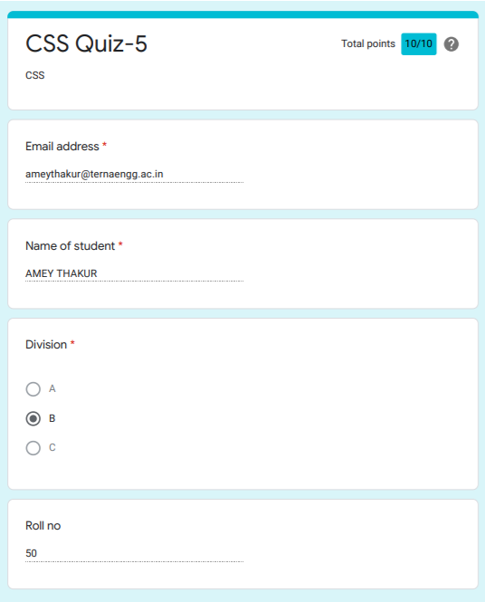

**CSS Quiz 6**

**Marks: (10/10)**

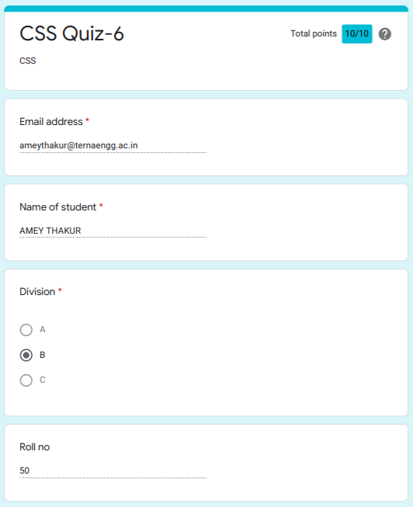

**IAT**

**CSS IAT 1**

**Marks: (18/20)**

**IAT 1 Descriptive Answer Sheet**

**(First page attached)**

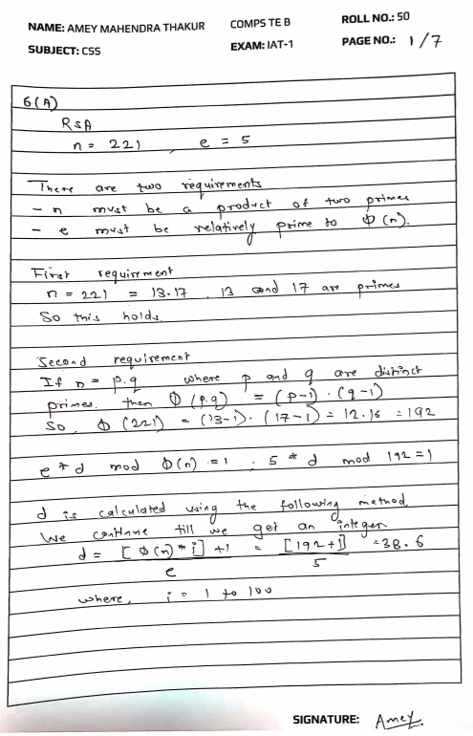

**CSS IAT 2**

**Marks: Not Received**

**IAT 2 Descriptive Answer Sheet**

**(First page attached)**

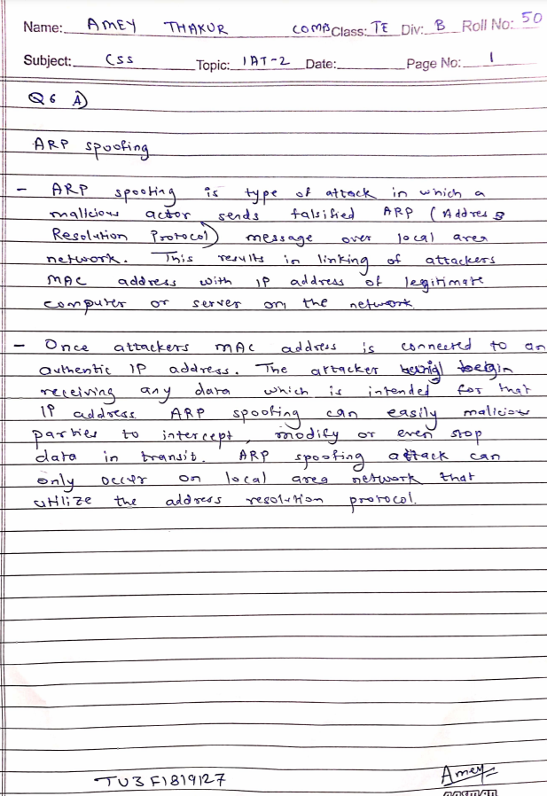

**Exit Survey**

**CSS Course Exit survey**

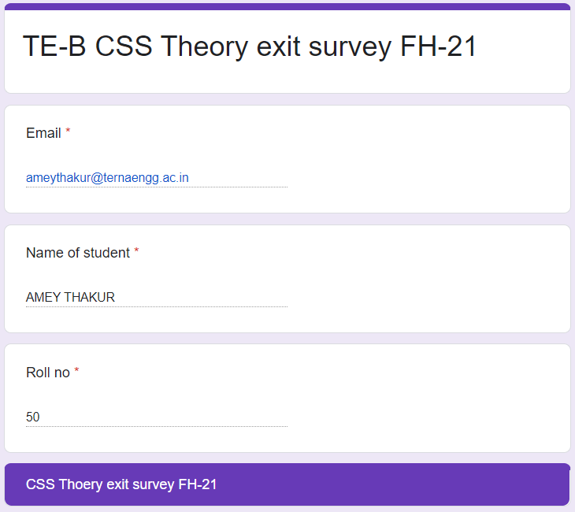

**CSS Laboratory Exit Survey**

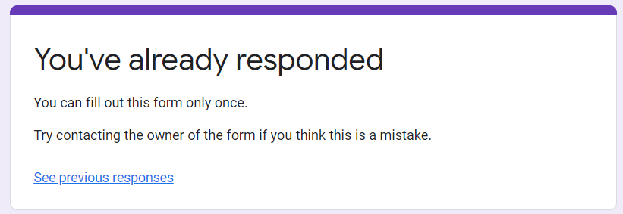

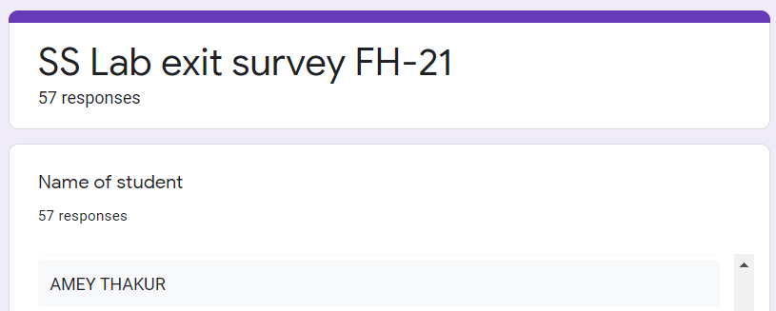

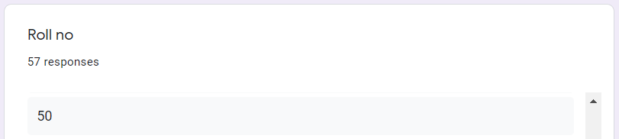

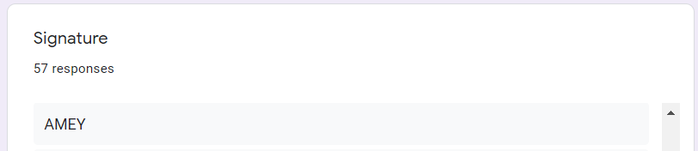

**Google Classroom Submission Report**

